# **Multiple Criteria Decision Support Systems**

# **TASK 1: Logic Scoring of Preferences, LSP**

The goal of this exercise is to use the LSP method to understand how to define utility functions to measure the suitability of a set of criteria. We will use a software developed at ITAKA research group of University Rovira i Virgili, available in the virtual campus. It is still a beta version, we apologize for any bugs, and we ask you to report them to the lecturers.

This example is a simplification of a decision support system for evaluating and selecting a TV shows. The system will consider 5 variables, grouped into two intermediate criteria: duration and content. The suitability (preference) scores given to the values of that variables depend on each decision maker. You will be the decision maker, so you must introduce the utility functions according to your preferences.

**You must make the tasks indicated below and prepare a detailed report. The report must include screenshots and explanations of the values introduced. It is highly important that you justify your decisions and answers in all the tasks. Deliver the report in the link provided in Moodle, at the date and time indicated.**

TASKS:

1. Open the software LSP-URV and create a tree of criteria starting from the root. Insert the nodes with the Add button. The tree to create is the following one.

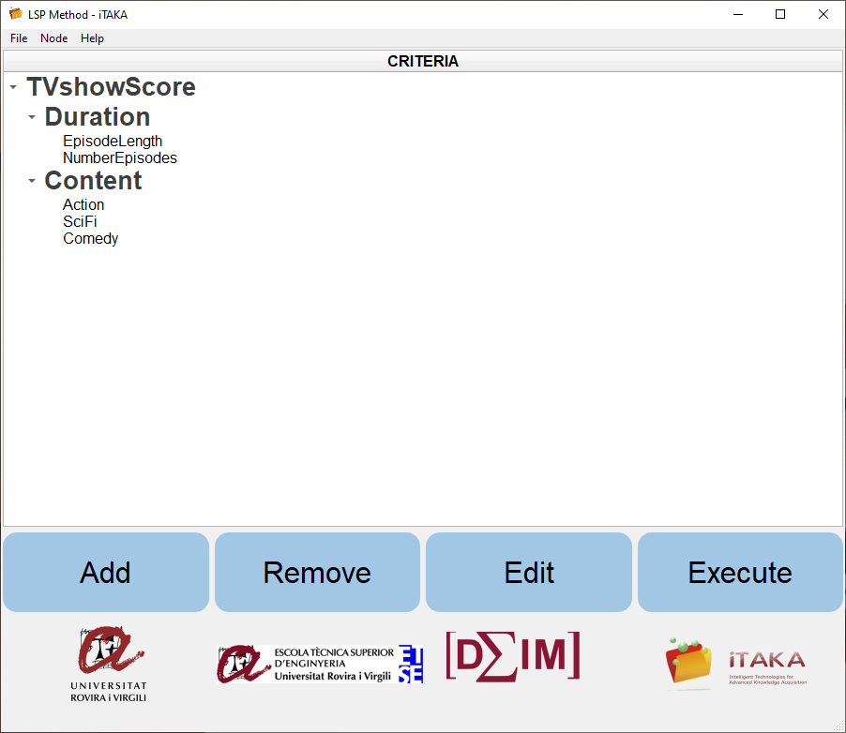

1. The configuration window (Edit button) allows you to introduce the type of node (leaf or not) and then, the corresponding paràmetres. In intermediate nodes, introduce the following parameters:
   * weights (sum must be 1 unit): consider equal weights in all cases.
   * For aggregation operator for merging the descendants, use following table:

|  |  |  |
| --- | --- | --- |
| TVshowScore | CA | Overall score of the TV show |
| Duration | C+ | Criterion about the length of the show |
| Content | DA | Criterion about the categories that define the type of show |

1. Introduce then the parameters for leaf nodes, at the lower-level criteria. You must define the appropriate utility function, following the indications given in the comments of each criterion.

You will start indicating the number of points you need to define the function. Then, a table as in the figure will appear. The values in the first column are given in the measurement units of the input variable (**ascending scale**), while the utilities must be in the range from 0 to 1 (**use “.” to indicate decimals**).

Episode Length

It evaluates your preference regarding the minutes of duration of each episode, which will be between 15 and 90 minutes.

Number of episodes

You must define the suitability (preference) with respect to the total number of episodes of the TV show. Let us consider a minimum of 5 episodes and maximum of 80.

Action

This criterion is based on a score that indicates the level of action in the TV show. Let us consider a measurement scale from 0 to 10.

Science-fiction

Similarly to previous criterion, this one is based on an score (0-5) that indicates if it is totally science-fiction (value 10), or completely reality based (value 0).

Comedy

Similarly to previous criterion, this one is based on an score (0-100) that indicates the percentage of comedy scenes in the show, from being totally a comedy (value 100), or otherwise a drama (value 0).

Your personal preferences regarding those variables will determine the utility functions you define.

**Save the tree and criteria before continuing (in File option).**

1. Press the “Execute” button to start the evaluation part. Introduce the following alternatives (i.e. universities). You can save the matrix before continuing.

|  |  |  |  |  |  |
| --- | --- | --- | --- | --- | --- |
| Name | EpisodeLength | NumEpisodes | Action | SciFi | Comedy |
| Fool me once | 50 | 8 | 3 | 0 | 100 |
| Big Bang | 20 | 80 | 0 | 2 | 70 |
| Bodies | 65 | 8 | 7 | 4 | 0 |
| Game of Thrones | 75 | 50 | 9 | 5 | 0 |
| Resilient Alien | 44 | 12 | 4 | 4 | 80 |

1. Press button “Calculate LSP” to run the utility functions to calculate the suitability table. Explain if the suitability values obtained for the 3 alternatives are correctly representing your preferences according to the utility functions.

Now we will study the aggregation procedure and the operators used in the different levels.

1. Observe the definition of the tree of criteria and the aggregation operators. Explain the polarity of the aggregation at each of the nodes. What does it mean?
2. Introduce the following new fictive alternatives and explain the results obtained:
   * A show that satisfies your preferences on both Duration and Content, but with at least one elementary criterion with low satisfaction performance.
   * A show with good performance in the Duration but a poor performance in the Content criterion. Explain how you have decided the values of the variables of this new alternative.
3. What happens if you increase the importance of the Duration criterion?
4. Return to the case of equal weights for Duration and Content, now, what happens if you change the polarity of the Duration aggregator?

*Remember that you must show screenshots of the steps done and results obtained, you must also properly discuss the results and their interpretation.*